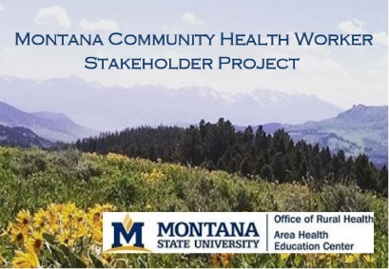

Summary of Employer Survey – Community Health Workers
HealthCARE Montana, February 2017

Responses
2017: 26 via Survey Monkey 2015: 69 via a more detailed phone survey

Organizations
- 11 Non-profits (Associations, FQHCs, Aging Services, MPQH)
- 10 Critical Access Hospitals
- 2 State Agency
- 2 Tribal Health
- 1 Long term care

Currently employ a CHW?
Yes – 10 (32%)
No = 21 (68%)

2015 survey
Yes – 27%
No - 72%

How many full time and part time Community Health Workers do you employ?

1 organization at less than 1 FTE
1 organizations at 1.5 FTE
2 organizations at 2 FTE
1 organization at 2.5 FTE
1 organization at 3 FTE
1 organization reported at 7 FTE
1 organization reported 4 FTE, 4 PT

2015 survey-Of the 25% survey respondents that indicated they currently employ CHWs, the total numbers of full time positions were 92 FTE and number part time CHW positions within their organizations are 38 PT.

Length of employment

2 – Less than one year
4 – One to four years
4 – Ten+ years

Populations Served

2017
10 Elderly
9 Rural
8 Low income
7 American Indian
4 Non-English Speakers
2 New mothers
1 Medicaid, full coverage eligible
2015
13 Elderly
10 Rural
9 Low income
8 American Indians
4 new mothers
3 Non-English speakers
1 Other

Sources of Funding
5-Government funds
4-Internal funds
4-Reimbursable cost (Insurance/Medicaid)
3-Foundation grants
Also: Community-based funding

