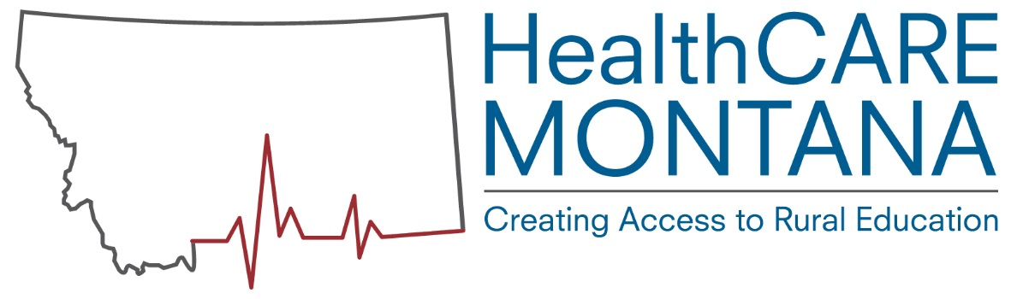

Nationally, Community Health Workers (CHW) are used in a variety of community and healthcare settings, with the primary goal of increasing access, delivering screening and preventive services, improving system navigation, care coordination and disease management. They enhance the cultural and community specific appropriateness of services, and help to address social determinants that impact health – including housing, safety, transportation, and poverty. Most profoundly, CHWs can reduce the social isolation and fears that exclude members of our communities from full participation in life and health. This is accomplished both through outreach as well as advocating for the community to the provider organizations.

CHW’s are most often part of a team, assigned to specific duties, clients, and activities. It is important in new models of care coordination and addressing social determinants of health, that there are clear role expectations, feedback mechanisms, and methods of communicating and documenting the work of CHWs. Their work should be incorporated into larger systems of care and services. Roles can include helping parents manage complex services for their children, chronic disease management, working with migrant or immigrant populations, connecting chronically ill elderly populations to services, providing community based services through Community Paramedic or EMTs, or delivering prevention services in community based settings.

CHWs can have a variety of titles such as community health representative, outreach worker, navigators, resource advocates or personal care attendants.

- How do you describe your organization?

11 or 42% Non-Profit (including associations, quality improvement organizations, FQHCs, In-home care, Assisted living and ALF
10 or 38% CAH
2 or 8% State agency
2 or 8% Tribal Health
1 or 4% Long term care

0 - City/County health, Tribal agencies, PPS hospitals, Home health, Public health, Veteran’s Association and SNAP/EFNEP

- Do you currently employ a Community Health Worker?

10 or 32% - Yes
21 or 68% - No

2015-Most survey respondents (72.5%) indicated that they are not currently employing CHWs, while 27.54% are currently employing CHWs.

- What title does your facility use for a person that performs the duties described above in your facility?

3 Personal Care Attendant
2 Community Health Worker
1 each Community Health Representative, Outreach Worker, Navigator, Resource Advocate, Outreach Specialist, Resource Coordinator, Patient Care Coordinator, Care Manager

- How many full time and part time Community Health Workers do you employ?

1 organization at less than 1 FTE
1 organizations at 1.5 FTE
2 organizations at 2 FTE
1 organization at 2.5 FTE
1 organization at 3 FTE
1 organization reported at 7 FTE
1 organization reported 4 FTE with 2 PART TIME and 2 PER DIEM

2015-Of the 25% survey respondents that indicated they currently employ CHWs, the total numbers of full time positions within their organizations are 92 FTE and number part time CHW positions within their organizations are 38 PT.

- How long have you employed Community Health Workers?

2 Less than one year
4 One-four years
0 Five-ten years
4 Ten plus years

- What qualifications are required for Community Health Workers employed at your facility? In rank order.

9 Background check
6 HIPAA training
5 High school diploma or GED
4 Auto insurance
4 Currant vehicle registration
3 CPR training
3 Medical background
3 Awareness of community resources
2 Drug test
1 CNA certification
1 Social service background
1 Case management experience
1 Live in community served
1 Comprehensive Alzheimer's and dementia care and support training
1 RN licensure
0 First Aid training

- Describe the difference in qualifications required for entry level and experienced workers.
Experienced workers will possess greater years in this or allied fields. They will be able to operate with more autonomy. Frequently they will possess specifically relevant or complimentary advanced education, experience and community networks.
CHW was here prior to my administration
[My organization]is willing to train employees if they have the mission of the organization in their heart. We have few requirements so we can hire the person best fit to treat the target population with compassion and respect and believe we can provide training in areas like community resources, HIPPA, case management etc.
Experienced workers will have a better knowledge of resources.
Entry level must have at least a diploma or GED as well as 16 hours of basic CNA training.

- What services are provided by the Community Health Workers that you employ? In rank order.

9 Underserved population
8 Promote preventive care
8 Help clients with paperwork
7 Transportation
7 Conduit for health care services
7 Education to clients on how to navigate and access health care
6 Nutrition education
6 Health promotion
6 Chronic disease management
5 Link uninsured to health care coverage
4 Conduit to health screenings

- What populations are served by the Community Health Worker? In rank order.

10 Elderly residents
9 Rural residents
8 Low socio-economic households
7 American Indians
4 Non-English speakers
2 New mothers
1 Medicaid, full coverage eligible

2015
13 Elderly residents
10 Rural residents
9 Low socio-economic households
8 American Indians
4 New mothers
3 Non-English speakers
1 Other

- Do you offer Community Health Worker training at your facility?

6 or 60.00% YES, please specify below
3 or 30.00% NO
1or 10% Don't know

- A variety of trainings online and in person on all matters related to Alzheimer's and related dementias. (Communications, behaviors, legal and financial, caring for a loved one in various stages of the disease, understanding the ten signs of AD, etc.)
- Our CHRs take an online program developed by the Indian Health Service
- 16 hours as required by state regulations
- Support with completing CEC, support becoming a chronic disease case manager, learning about communication resources, translation best practices
- Chronic Care Professional Certification
- 16 hours of basic CNA training

- Please provide minimum/maximum hourly salary range for Community Health Workers at your facility.

$9.35 - $13.07
$10.00 - $12.00
$11- $20
$12 - $17
$14.00 - $17.00
$14-$26 RNs would be in the higher range.
$14.06 - $16.33
$16.51 - $22.94 with full benefits
$24.00 - $36.00

2015-Survey respondents indicated a range for salary for FTE as $12 to $14, plus benefits.

- How do you fund the Community Health Worker position at your facility?

5 Government funds
3 Foundation grants
4 Internal funds
4 Reimbursable cost (insurance/Medicaid)

Also:
Community-based fundraising
Currently part time employee

2015-Many survey respondents (75%) indicated government grants as a funding source which include but are not limited to the Federal Farm Bill, IHS, and Medicare.

Other survey participants indicated “Other” (18.75%), “Reimbursable cost (12.5%), “Foundation grants” (6.25%), and “Internal funds” (6.25%) as sources of funding for financing CHW positions.

- What method(s) does your facility use to recruit Community Health Workers?

9 Internal recruiting
8 Online advertising
8 Newspaper
2 Community events
2 Employment agencies

- If you do not employ Community Health Workers, how likely are you to employ them in the future?

3 or 11% Highly likely
2 or 7% Somewhat likely
2 or 7% Likely
2 or 7% Somewhat unlikely
2 or 7% Highly unlikely
9 or 32% Don't know
8 or 29% Not applicable

2015-Approximately 12% of survey respondents stated they would “Likely” employ CHWs in the future, while 27.5% indicated that they were “Not sure” if CHWs would be hired in the future. 36% of survey respondents also specified that they would not hire CHWs in the future.

- Should the state of Montana have a standardized program for Community Health Workers?

21 or 70.00% YES
1 or 3% NO
8 or 26.67% No opinion

2015-YES-17 or 77%, NO-5 or 23%. Several respondents expressed an interest in standardized training, but noted that they felt they would still need specialized training for their circumstance. Some expressed an interest in “training in place” rather than going off-site.

- What delivery method would be best for standardized Community Health Worker training? In rank order.

27 or 87% On-the-job training
25 or 81% Online coursework
21 or 68% Classroom
21 or 68% Video-conferencing
19 or 61% 19Self-study
Other-A combination webinar and classroom

- Are you interested in assisting in the promotion of the use of Community Health
Workers in MT? In what way?

Show that we are interested and how it would benefit our seniors
Yes. I oversee several federal grants that are allocated to the local county health departments. A well trained CHW could fulfill the grant deliverables.
Certainly. For all topics related to Alzheimer's and other dementias.
Not now.
Yes - community health workers would greatly enhance our care coordination work.
Yes - by employing the community health worker full time
We use to do this but with the funding not available our small hospital was not able to continue
No
No
MHREF would be interested in supporting the delivery of on-line instruction (like the CNA Academy) and promoting CHWs to MHA members possibly using them as transition coordinators and plan facilitators
Yes
CHP may be willing to help. It would depend on the commitment level and how the program was structured.
No
Not sure
Would be happy to help if it doesn't require too much of a time commitment from us.
Yes - it seems like peer support in some ways although they don't have to have been in the patient's shoes but helps to understand the culture of the group that the patient belongs to
Help with curriculum On-the-job training
Yes. However you need me to.

- Are you aware of other organizations in your community that may employ Community Health Workers? Please list including contact information.

Big Horn Valley Health Center Hardin
Public health, St. Peter's Hospital
Gallatin County Health Department
Crestwood Inn--Licensed Social Worker

