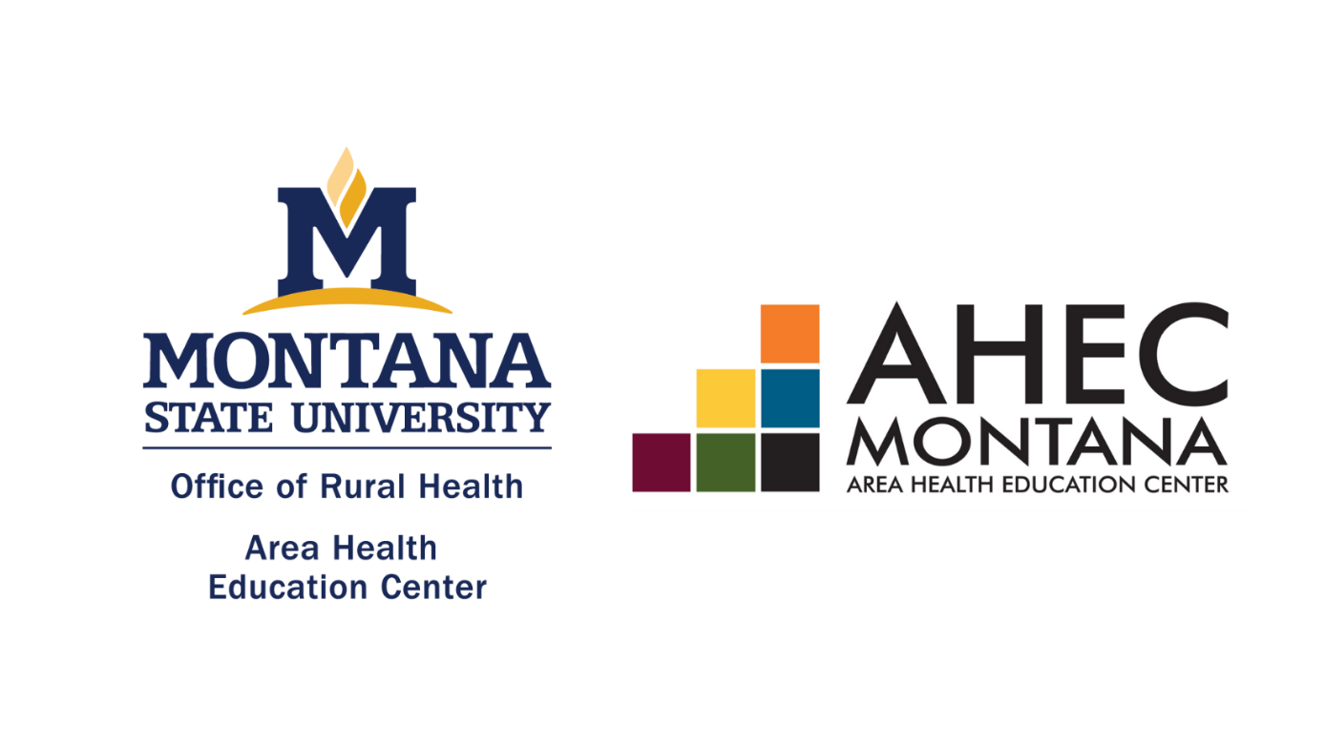
Montana American Indian AHEC Center
Request for Proposal - Due January 31, 2024
Fall 2023

PURPOSE OF THE REQUEST FOR PROPOSAL

The Montana Area Health Education Center (AHEC) program is a federally funded initiative that aims to enhance access to quality healthcare, particularly primary and preventive care, by improving the supply and distribution of healthcare professionals through community and academic educational partnerships.

The organization selected to host a Montana American Indian AHEC Center will lead the collaborative effort to join the other Montana regional entities to develop new and enhance existing programs while furthering state, education, and community interests addressing healthcare workforce concerns. This proposal seeks to allow candidates to apply to be the American Indian AHEC Center in Montana.

Award of the host agency resulting from this RFP will be based upon the most responsive applicant whose proposal meets the criteria of sponsoring the Montana American Indian AHEC in terms of collaboration, functionality, feasibility, and other factors as specified in this RFP, in addition to a full selection committee review.

All organizations committed to supporting statewide healthcare workforce relationships with tribal nations and communities across the Montana are welcome to apply.

POINT OF CONTACT
Name:
Title/Role:
Organization:
Address:
Email Address:
Phone Number:

Per HRSA guidelines (HRSA-22-053), the AHEC center shall meet the following requirements:

- The center is a public or private organization whose structure, governance, and operation is independent from the recipient and the parent institution of the recipient (Montana State University);
- The center is not a school of medicine or osteopathic medicine, the parent institution of such a school, or a branch campus or other subunit of a school of medicine or osteopathic medicine or its parent institution, or a consortium of such entities;
- The center fosters networking and collaboration among communities and between healthcare organizations;
- The center serves communities with a demonstrated need of health professionals in partnership with healthcare organizations;
- The center addresses the health care workforce needs of the communities served in coordination with the public workforce investment system;
- The center has a community-based governing or advisory board that reflects the diversity of the communities involved;
- The center will support student enrollment into the Montana AHEC Scholars Interprofessional Education Program; and
- The center provides quarterly updates during the project period and complies with all HRSA and AHEC program reporting requirements.

Does the applicant organization agree to meet the above requirements: Yes / No

FINANCIAL SUPPORT
Funding for the American Indian AHEC Center is as follows:
Years 1 & 2 Start Up (2023-24 & 2024-25): $187,500*
Years 3 & 4 Maintain (2025-26 & 2026-27): $110,693*
*Unless funding disbursement is changed by HRSA.

Each fiscal year for the AHEC center is September 1 – August 31.
In Year 5, Montana AHEC will apply for the next competitive funding application for the five-year HRSA AHEC grant.

Requirements of the federal grant include a 1:1 cost match for grant awardees. Direct support should be at least 25% of this match. A match waiver for the new center has been requested.

If the match waiver is not available, would your organization be able to meet the 1:1 cost match with 25% of the funds being cash match each fiscal year? Yes/No

ORGANIZATION BACKGROUND – 500 words each
- Please provide information about the organization, its role in Montana, and the population it serves. Please also address the organization’s experience effectively working with tribal populations across the state (i.e. all reservations and urban communities).
- Please describe how the organization plans to or currently gathers knowledge and builds relationships and trust with tribal communities across the state.
- Please describe the benefits/advantages/value of an AHEC center at the proposed host organization. How does the host organization align with the goals and mission of Montana AHEC?

AHEC OPERATIONS AND ACTIVITIES - 300 words each
Applicants must articulate their capacity to carry out the following activities outlined in the HRSA-approved Montana AHEC workplan. A framing committee will be provided to support the development of the new center’s formal workplan.

- Please summarize the capacity the proposed center has to conduct community-based health care workforce development and support in underserved and disadvantaged and rural areas.
- Please explain how the proposed center will effectively develop and implement strategies to recruit American Indian students into health professions.
- Please explain how the proposed center will effectively develop and implement strategies to foster and provide community-based training and education to American Indian people seeking health professions training.
- Please explain how the proposed center will effectively provide interdisciplinary healthcare training opportunities to American Indian healthcare workers and students across Montana.
- Please explain how the proposed center will effectively facilitate continuing education and information dissemination for American Indian health care professionals.

STAFFING
Each AHEC Center is required to have a .75 FTE Director.

- Please indicate if a new director would be hired or if an existing employee will perform the duties of the AHEC Director:
- Provide a staffing plan that identifies and justifies staff required at the proposed center.

PARTNERSHIP SUPPORT
- Please provide three letters of support from key partners from the local, regional, and state level who can endorse your proposed center’s application and speak to your successful collaboration with Tribal partners. Each letter is to be limited to one page.

QUESTIONS:
Kailyn Mock, Director kailyn.mock@montana.edu 406.994.7709

