|  |
| --- |
| **Montana Community Health Worker Bulletin** |

|  |  |
| --- | --- |
| |  | | --- | |  | |

**What is a Community Health Worker?**

A Community Health Worker (CHW) is a frontline public health worker who is a trusted member of and/or has a close understanding of the community served.

The trusting relationship enables the CHW to serve as a liason/link/intermediary between health and social services and the community to facilitate access to services and improve the quality and cultural competence of service delivery.

A CHW also builds individual and community capacity to increase health knowledge and self-sufficiency through a range of activities such as outreach, community education, informal counseling, social support and advocacy.

Other Job Titles - Case Manager, Care Coordinator, Outreach Worker, Patient Navigator, Community Resource Specialist

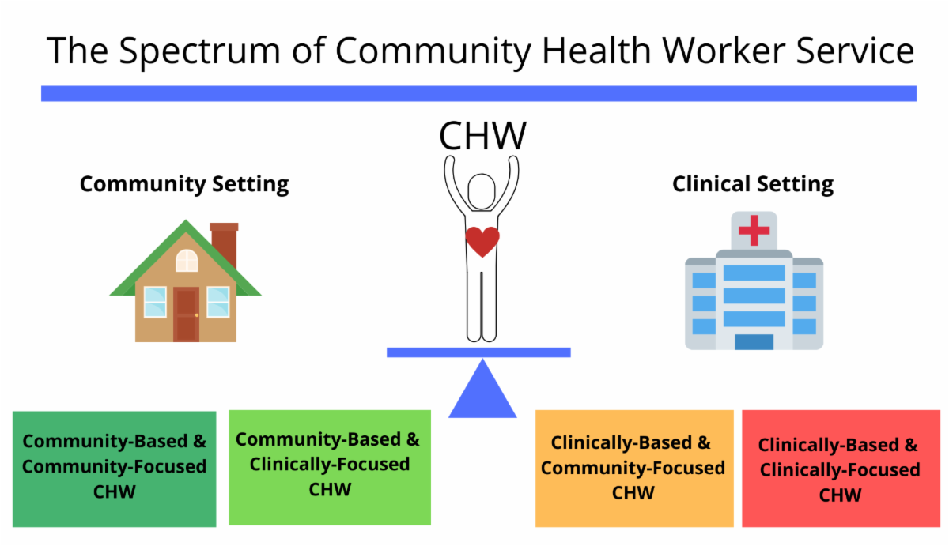

**Article Spotlight**

"I Hired a Community Health Worker and Now We Work Miracles"

One rural West Virginia physician's

account of the invaluable work her Community Health Worker does for her patients. "Patients need doctors, but aren't all they need to achieve better health. Sometimes they need things that seem impossible, and somehow community health workers make miracles happen." This article highlights the amazing work CHWs are doing across the nation, by bridging the gaps in patient care outside of the doctor's office.

Click [here](https://www.aafp.org/news/blogs/freshperspectives/entry/20180917fp-commhealth.html) for the full article on AAFP.

|  |  |
| --- | --- |
| |  | | --- | |  | |

**Community Health Worker Training**

Montana ORH/AHEC provides full tuition

reimbursement for a number of behavioral health trainings, including the Community Health Worker training. The CHW training consists of four online, instructor-lead learning modules (15- hours each), plus a 25-hour supervised experience component.

Check out the CHW training library with a number of add-on modules in a variety of topics including: Basics of Diabetes, Adult Mental Health, Geriatric Fall Prevention, Substance Use Disorder, Alzheimer's Disease, and Communication & the Elderly. Modules are continually being added to the library.

Click [here](https://morhahec.teachable.com/courses) to access the CHW training library.

Apprenticeship Option – to learn more about a Community Health Worker apprenticeship, please email [apprenticeship@mt.gov](mailto:apprenticeship@mt.gov) or call 406-444-4100

For more information on available behavioral health trainings, visit: [healthinfo.montana.edu](http://r20.rs6.net/tn.jsp?f=0015JtScuerWI5HoccDnOd8ZTZrSKLfoxhVvBIqlbbUj3qBCcfTaokMFLm0XoWjY1FTXb0r_hCC-xWIybYYkuwp19X8VWXKDvN5C_dx3TxtuWNpid1kwQ2GP8_BzBPtywrHW-ozE-N6GH85D8lOh6FtGgSIUfBawHzm3XenAUL3k1Wn-LOOYC8oiA==&c=8BJbBnUY8ZOAsooTxqcKYw9wJeWoyIslwOhLS1sfG8eVzpahDGwE-A==&ch=2RFipb-NlSMrI_Ah3uuoqrXYOkCU8Tx1N5FRsYhu78VGGW3-RwpTBg==)



**Reimbursement for Services**

The million dollar question when the topic of utilizing Community Health Workers comes up: "How do we pay for them?"

Programs across the nation are struggling with this very question. Many are using grant funds and hoping to work their way into a sustainable model. Some have worked them into their operating budgets as they have seen the cost savings firsthand while employing CHWs.

At this time there are three reimbursement codes that are recognized globally for CHW service:



* CPT: 98960 - Education and training for patient self-management by a qualified, non-physician health care professional using a standardized curriculum, face-to-face with the patient (could include caregiver/family) each 30 minutes; individual patient
* CPT: 98961 - Education and training for patient self-management by a qualified, non-physician health care professional using a standardized curriculum, face-to-face with the patient (could include caregiver/family) each 30 minutes; 2-4 patients
* CPT: 98962 - Education and training for patient self-management by a qualified, non-physician health care professional using a standardized curriculum, face-to-face with the patient (could include caregiver/family) each 30 minutes; 5-8 patients

MORH/AHEC is working hard to come up with solutions to this very question for organizations that want to employ Community Health Workers. For more information on these efforts, or if you would like to share how your organization is paying for CHW services, please contact: Beth Ann Carter

[beth.carter@montana.edu](mailto:beth.carter@montana.edu) or 406.925.1261

|  |  |
| --- | --- |
| |  | | --- | |  | |

|  |
| --- |
|  |

**Montana Community Health Worker Association**

If you know a CHW or are yourself one, please let us know!

We are in the beginning stages of establishing Montana's first CHW Association and want to keep Montana's CHWs up-to-date on the Association, trainings, conferences, and other important items pertaining to CHWs.

Please contact Beth Ann Carter for more information and to be put on the email list. [beth.carter@montana.edu](mailto:beth.carter@montana.edu)  406.925.1261

